Dear Resident,

Brick manufacturing has played a significant role in contributing to the township of Byford since the 1890’s. Austral Bricks® WA is proud to be a part of the local community and will continue to support the region through investment and employment opportunities.

Brickmaking will recommence at the site in late 2020 under existing planning and environmental approvals. The brick plant has been in care and maintenance since September 2019, however Austral Bricks® WA has maintained its presence in the area during that time by means of clay extraction and despatch of bricks.

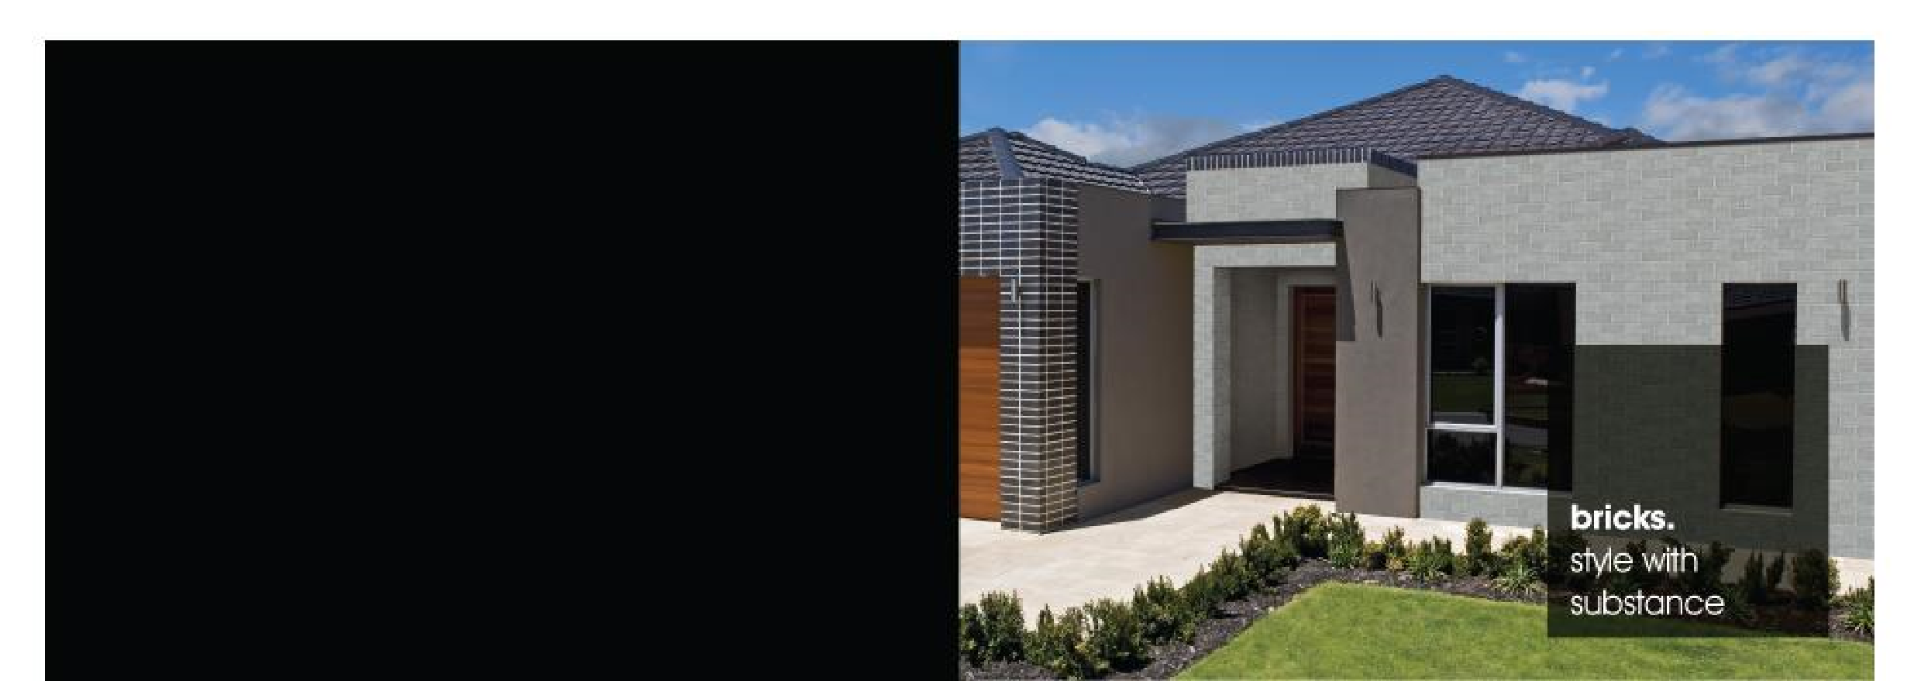
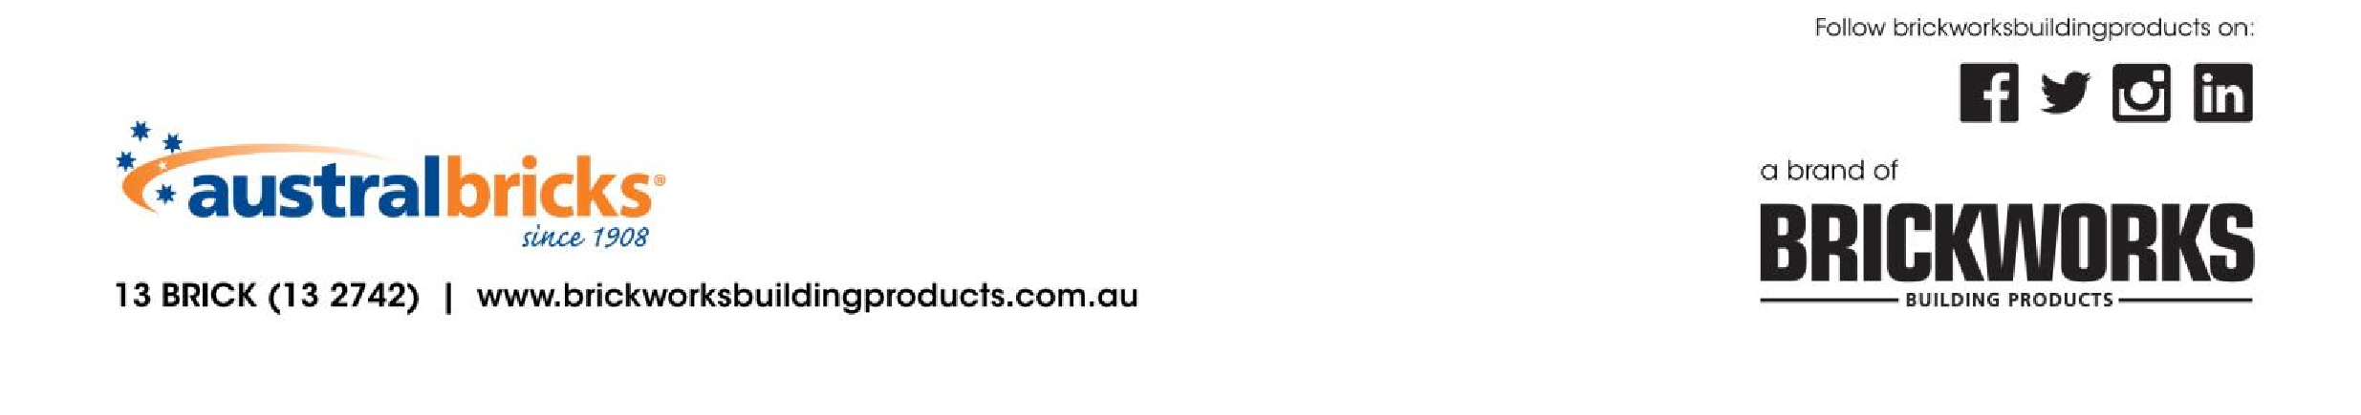
Austral Bricks® WA is committed to managing its operations in a manner so it does not affect the community and environment. We are pleased to be able to bring back employment opportunities to the area and improve the local economy.
Re
-
Opening of
Cardup Brick Plant

17 June 2020

In addition to our recent investments in 2015, Austral Bricks® WA has applied for planning approval for an upgrade of the factory which sets out to modernize the kiln, dryers and crushing equipment with the latest brickmaking technology available. The proposed upgrade will include many environmental benefits including the replacement of the existing kiln with a highly efficient natural gas fired kiln and baghouse scrubber.

Full details of the proposal are available online at www.sjshire.wa.gov.au.

If you have any questions or would like further information on the proposed upgrade, please don’t hesitate to email environmentalwa@brickworks.com.au.

Kind regards

David Johnson
General Manager WA
Brickworks Building Products

